**[25] Design DFA Which Accepts String That Either Starts With ‘A’ Or ‘B’**

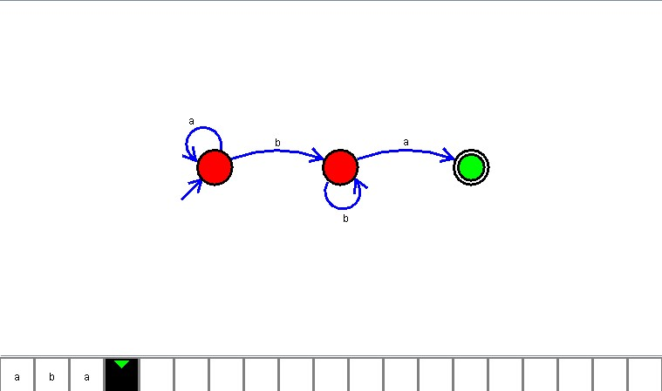

**Result**

The DFA is designed to compute the strings as input using Automaton Simulator which accepts string which starts with ‘a’ or ‘b’